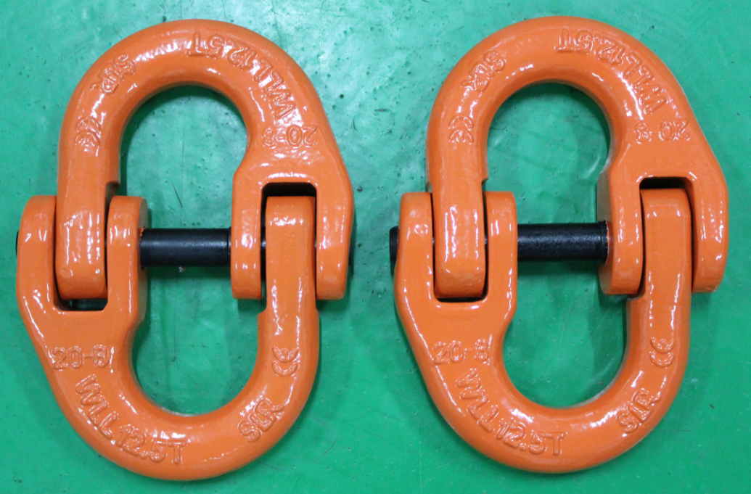**G80级双环扣**

|  |  |  |  |  |  |  |  |  |
| --- | --- | --- | --- | --- | --- | --- | --- | --- |
| **G80级 双环扣（G80 CONNECTING LINK)** | | | | | | | | |
| **PL03-G80 CONNECTING LINK G80级 双环扣** | | | | | | | | |
| ITEM CODE 货号 | G80 EN818-2 CHAIN 配合80级链条尺寸 | WEIGHT (KG) 单重 | WLL(T) 工作拉力 | DIMENSION(MM)尺寸 | | | | |
| A | B | L | K | H |
| PL03-6 | 6 | 0.08 | 1.12 | 15 | 7.5 | 58 | 42 | 7 |
| PL03-7 | 7 | 0.145 | 1.5 | 19 | 8.5 | 71.8 | 54.8 | 8.5 |
| PL03-7/8 | 7/8 | 0.146 | 2 | 18 | 9.5 | 79.5 | 60.5 | 8.5 |
| PL03-8 | 8 | 0.16 | 2 | 19.5 | 9.5 | 79.5 | 60.5 | 8.5 |
| PL03-10 | 10 | 0.3 | 3.15 | 25 | 12 | 90.5 | 68 | 11.5 |
| PL03-13 | 13 | 0.65 | 5.3 | 29 | 15 | 117 | 87 | 15 |
| PL03-16 | 16 | 1.15 | 8 | 34.5 | 19.8 | 148 | 108.4 | 19.8 |
| PL03-18 | 18 | 1.84 | 10 | 38 | 21 | 154 | 112 | 21 |
| PL03-20 | 20 | 2.1 | 12.5 | 41 | 24 | 169.5 | 121.5 | 24 |
| PL03-22 | 22 | 2.87 | 15 | 48 | 26 | 193.5 | 141.5 | 26 |
| PL03-26 | 26 | 4.5 | 21.2 | 57.5 | 31 | 220 | 158 | 30 |
| PL03-32 | 32 | 8.21 | 31.5 | 67 | 38 | 281 | 205 | 37 |
| 破断拉力是工作拉力的4倍。 | | | | | | | | |
| **警告：绝对不能超过工作拉力使用** | | | | | | | | |